Session 17 - Modules & Packages: Task Report

Task 1: math.sqrt()
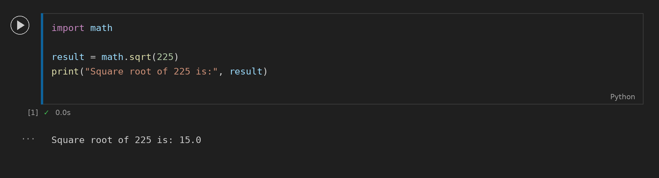

Task 2: Create Folder with os
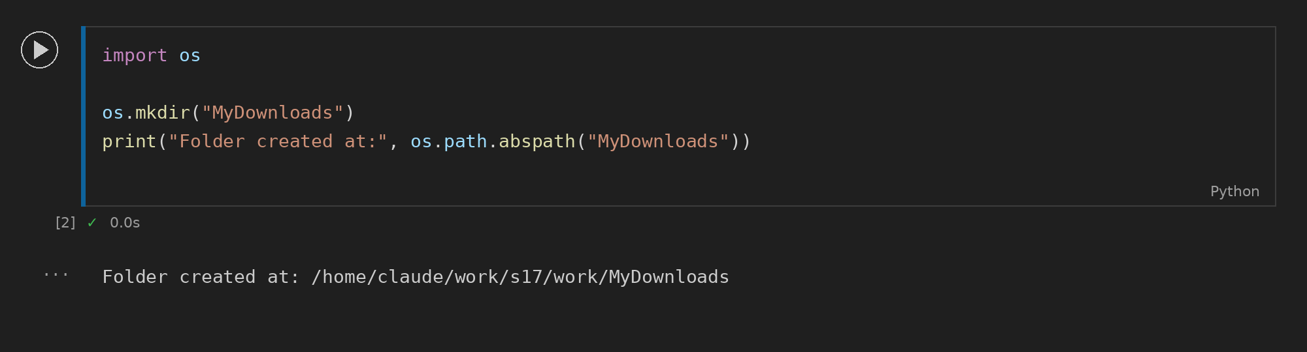

Task 3: Date and Time Formatting
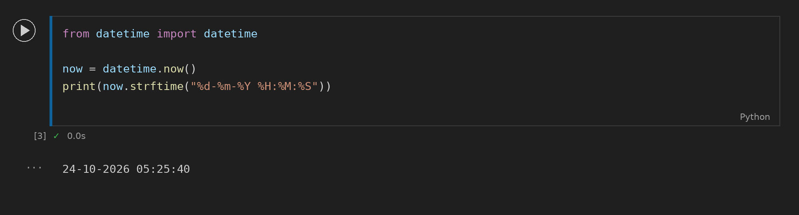

Task 4: Custom playlist_utils Module
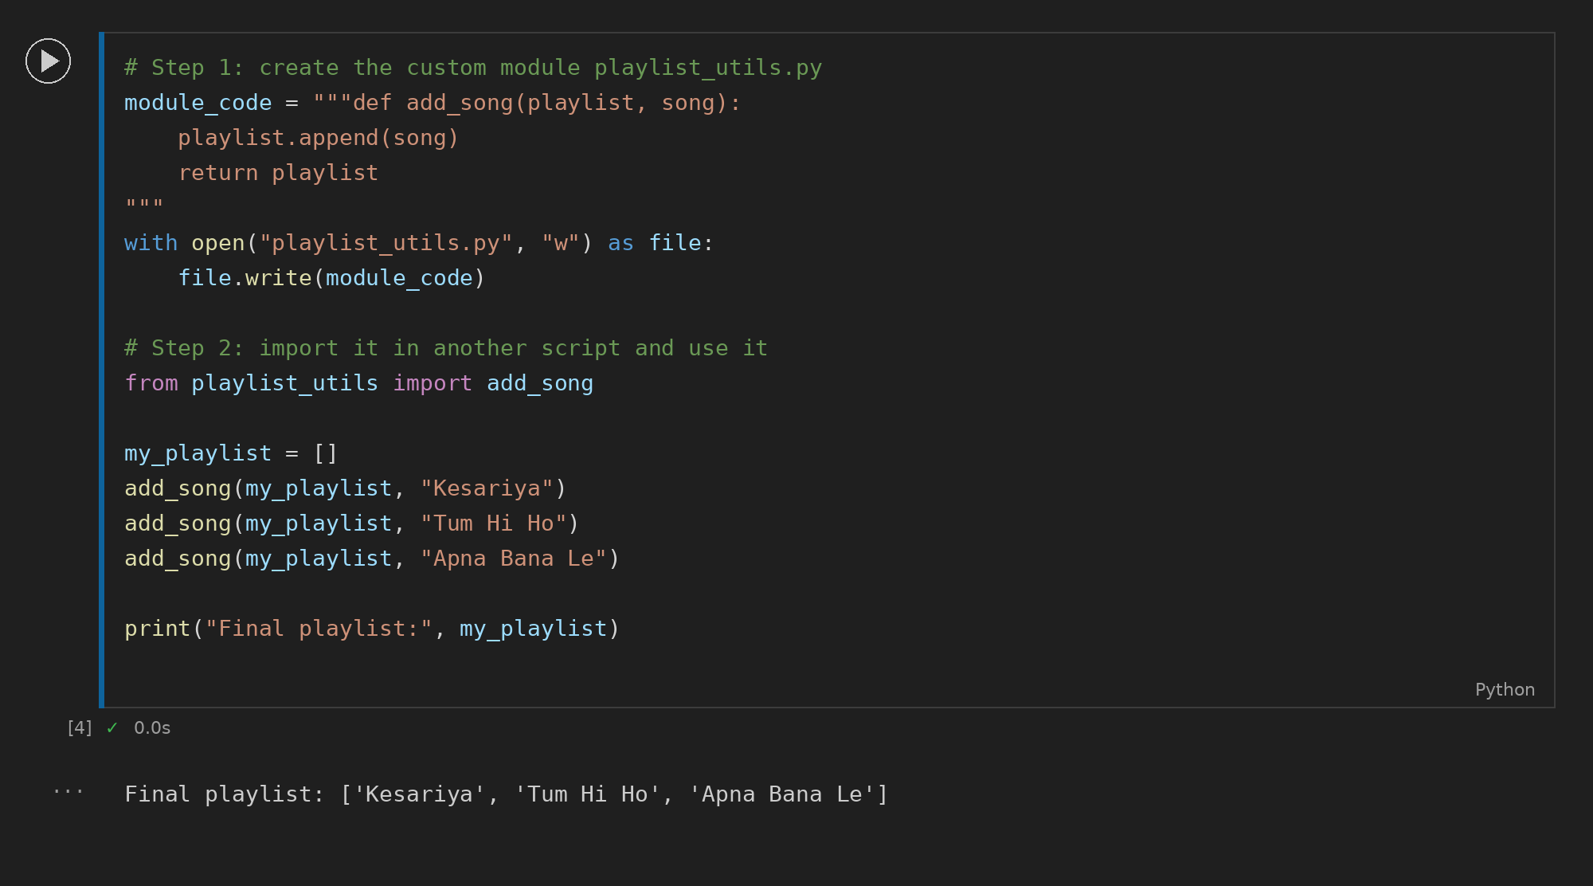

Task 5: Virtual Environment and requests
